**Laboratory Assignment 3: Integrated Circuit Digital Logic Gates**

**ECE 0201: Digital Circuits and Systems**

**45 Points**

**Name**

张鹤扬 Stefan Zhang

**Submission Checklist:**

 Write within boxes, do not move boxes

 Write your full name in the box above

 Save this file as a PDF before uploading, keep the number of pages (**9**) unchanged

 Note “TO BE CONTINUED” in the answer box if you used the extra pages (7-9)

**Part I: Integrated Circuits (9 points)**

**2-input NAND gate using CD4007**

[(A) Insert a picture of your build of the circuit in Figure 5] (2 points)

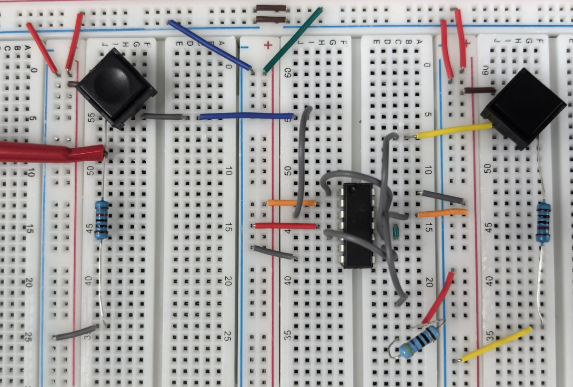

[(B) Fill out the following information] (4 points)

|  |  |  |  |  |  |
| --- | --- | --- | --- | --- | --- |
| S1 (A) | S2 (B) | VA | VB | VOut | LED (on/off) |
| Open | Open | -0.005mV | 0.2675mV | 4.9989V | ON |
| Open | Closed | 0.001mV | 4.9989V | 4.9989V | ON |
| Closed | Open | 4.9986V | 0.0769mV | 4.9987V | ON |
| Closed | Closed | 4.9985V | 4.9985V | 0.891mV | OFF |

[(C) Select a logic abstraction, draw a truth table for the inputs and outputs] (3 points)

Logic abstraction: NAND gate

Input for switches: open is 0, closed is 1

Output for LED: ON is 1, OFF is 0

The chart shows that the output is 0 only if two switches are closed, which can be regarded as NAND logic gate.

|  |  |  |
| --- | --- | --- |
| S1 | S2 | Result |
| 0 | 0 | 1 |
| 0 | 1 | 1 |
| 1 | 0 | 1 |
| 1 | 1 | 0 |

**Part II: 7400-Series Logic C (10 points)**

[(A) Fill out the following information] (2 points)

Number of transistors in the 7402: 16

[(B) Insert a picture of your circuit] (2 points)

架子上整齐的摆放着一些物品

AI 生成的内容可能不正确。

[(C) Fill out the following table] (4 points)

|  |  |  |  |  |
| --- | --- | --- | --- | --- |
| S1 | S2 | VA | VB | VOut |
| Open | Open | 8.720mV | 8.204mV | 4.9987V |
| Open | Closed | 0.456mV | 4.9978V | 5.070mV |
| Closed | Open | 4.9978V | 0.049mV | 2.448mV |
| Closed | Closed | 4.9978V | 4.9976V | 0.299mV |

[(D) Draw a truth table for the gate] (2 points)

Logic abstraction: NOR gate

Input for switches: open is 0, closed is 1

Output for LED: ON is 1, OFF is 0

The chart shows that the output is 1 only if two switches are open, which can be regarded as NOR logic gate.

|  |  |  |
| --- | --- | --- |
| S1 | S2 | Result |
| 0 | 0 | 1 |
| 0 | 1 | 0 |
| 1 | 0 | 0 |
| 1 | 1 | 0 |

**Part III: Design of an Exclusive-OR Circuit (26 points)**

[(A) Draw a truth table for a 2-input exclusive-OR (XOR) gate] (2 points)

Input for switches: open is 0, closed is 1

Output for LED: ON is 1, OFF is 0

|  |  |  |
| --- | --- | --- |
| S1 | S2 | Result |
| 0 | 0 | 0 |
| 0 | 1 | 1 |
| 1 | 0 | 1 |
| 1 | 1 | 0 |

[(B) Write a logic function that represents the exclusive-OR operation] (2 points)

$$A⊕B=\left(A\overline{B}\right)+\left(\overline{A}B\right)$$

B

F

A

[(C) Draw a circuit that implements your logic function for the exclusive-OR operation] (2 points)

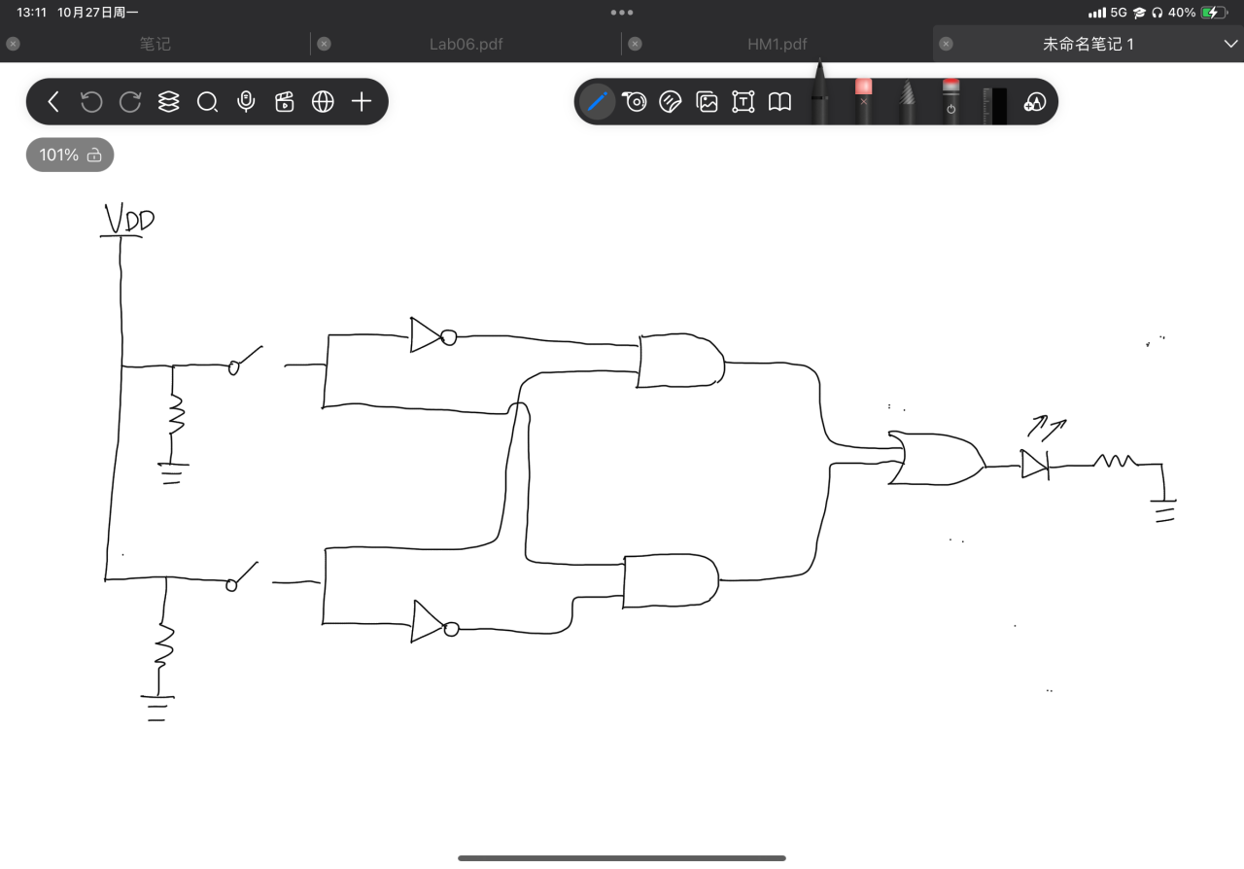

[(D) Insert a picture of your circuit] (2 points)

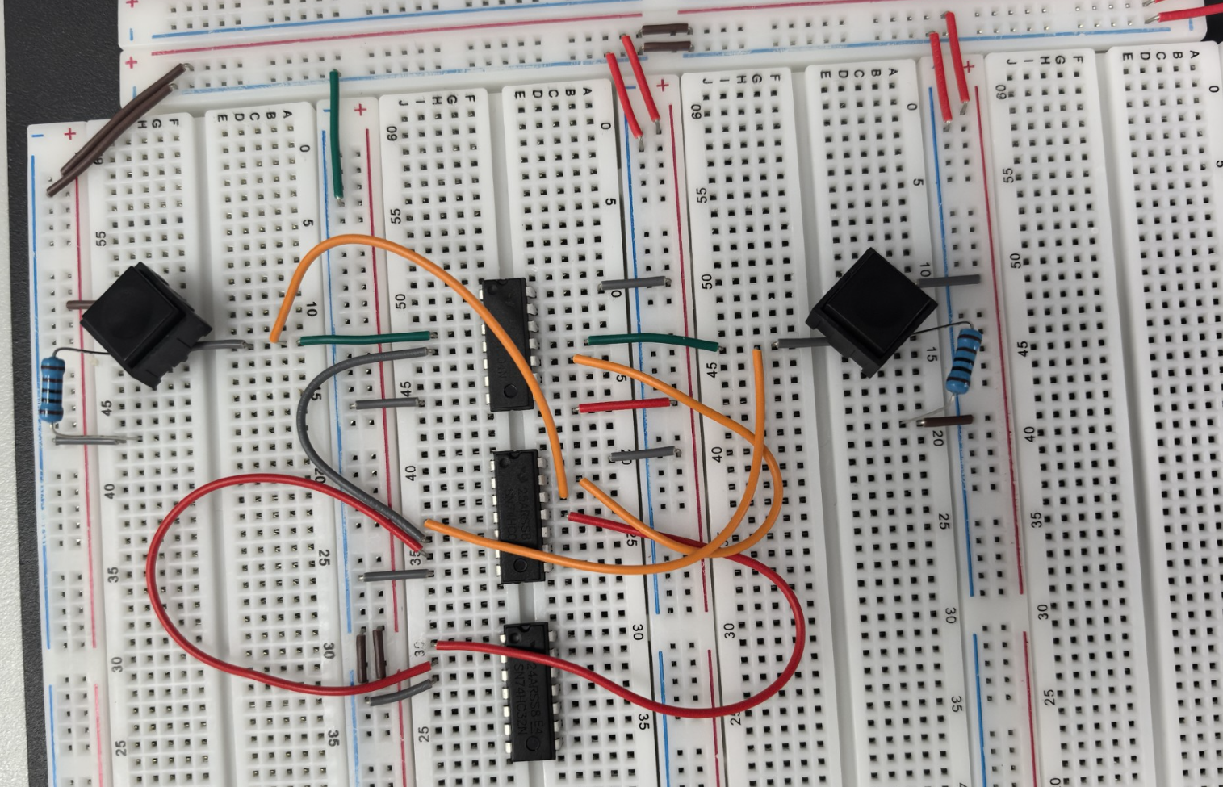

[(E) Fill out the following table] (4 points)

|  |  |  |  |  |  |
| --- | --- | --- | --- | --- | --- |
| S1 | S2 | VA | VB | VOut | LED (on/off) |
| Open | Open | 0.007mV | 0.006mV | 3.753mV | OFF |
| Open | Closed | 1.626mV | 4.9941V | 4.5053V | ON |
| Closed | Open | 4.9932V | 0.534mV | 4.5071V | ON |
| Closed | Closed | 4.9972V | 4.9973V | 4.967mV | OFF |

[(F) Draw a truth table of your circuit] (2 points)

Input for switches: open is 0, closed is 1

Output for LED: ON is 1, OFF is 0

|  |  |  |
| --- | --- | --- |
| S1 | S2 | Result |
| 0 | 0 | 0 |
| 0 | 1 | 1 |
| 1 | 0 | 1 |
| 1 | 1 | 0 |

The chart indicates that the output is 1 when two input are different.

**[(G) Demonstrate constructed circuit to TA for check-off] (12 points)**

**EXTRA PAGES**

[Leave the page unchanged if you are not going to use. Otherwise, specify the problem number you are working on here. Don’t forget to notify “TO BE CONTINUED” in the original problem box]

**EXTRA PAGES**

[Leave the page unchanged if you are not going to use. Otherwise, specify the problem number you are working on here. Don’t forget to notify “TO BE CONTINUED” in the original problem box]

**EXTRA PAGES**

[Leave the page unchanged if you are not going to use. Otherwise, specify the problem number you are working on here. Don’t forget to notify “TO BE CONTINUED” in the original problem box]